**Program 8:**

Design and implement C/C++ program to find a subset of a given set S={S1, S2, ……….., Sn} of n positive integers whose sum is equal to a given positive integer d.

**Algorithm:**

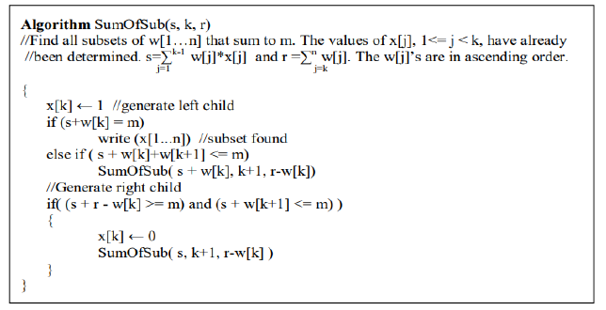

**Code:**

#include<stdio.h>

int x[10],w[10],count,d;

void sum_of_subsets(int s, int k, int rem)

{

x[k]=1;

if(s+w[k]==d)

{

printf("subset=%d\n",++count);

for(int i=0;i<=k;i++)

if(x[i]==1)

printf("%d ",w[i]);

printf("\n");

}

else

if(s+w[k]+w[k+1]<=d)

sum_of_subsets(s+w[k],k+1,rem-w[k]);

if((s+rem-w[k]>=d)&&(s+w[k+1])<=d)

{

x[k]=0;

sum_of_subsets(s,k+1,rem-w[k]);

}

}

int main()

{

int sum=0,n;

printf("enter number of elements:");

scanf("%d",&n);

printf("enter the elements in increasing order:");

for(int i=0;i<n;i++)

{

scanf("%d",&w[i]);

sum=sum+w[i];

}

printf("enter the sum:");

scanf("%d",&d);

if((sum<d) || (w[0]>d))

printf("No subset possible\n");

else

sum_of_subsets(0,0,sum);

}

**Output:**

